**Assignment no 2**

**1)**

**#include <stdio.h>**

**int main()**

**{**

**char array[25] = "C programming language";**

**printf("%s\n", array);**

**return 0;**

**getch();**

**}**

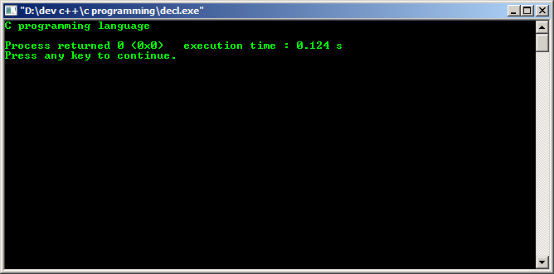

**2)**

**#include <stdio.h>**

**int main()**

**{**

**int a;**

**printf("Enter the value:");**

**scanf("%d", &a);**

**printf("%d\n", a);**

**return 0;**

**getch();**

**}**

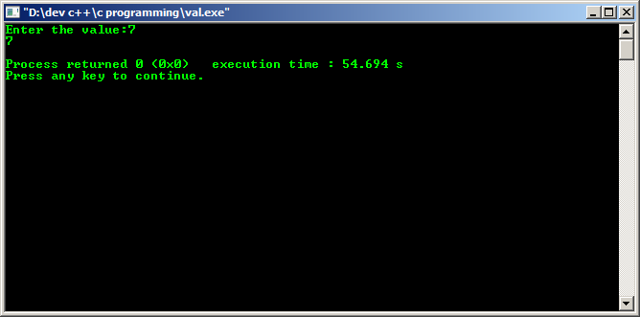

**3)**

**#include <stdio.h>**

**int main()**

**{**

**int marks=88;**

**char name[10]= "patkar";**

**printf("name is : %s" ,name ) ;**

**printf(" marks: %d", marks);**

**printf("\nName: %s \tMarks=%d \n",name,marks);**

**getch();**

**}**

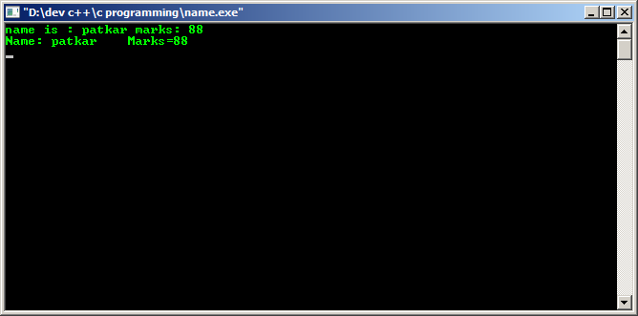

**4)**

**#include <stdio.h>**

**int main()**

**{**

**int Emp_id, Emp_sal;**

**char name[10];**

**printf("enter the emp_name :") ;**

**scanf("%s", name);**

**printf(" enter Emp_id:");**

**scanf("%d", Emp_id);**

**printf("enter the emp_sal :") ;**

**scanf("%f", Emp_sal);**

**printf("\nEmp_Name: %s \t Emp_id=%d \t Emp_sal=%f \n",name,Emp_id,Emp_sal);**

**getch();**

**}**

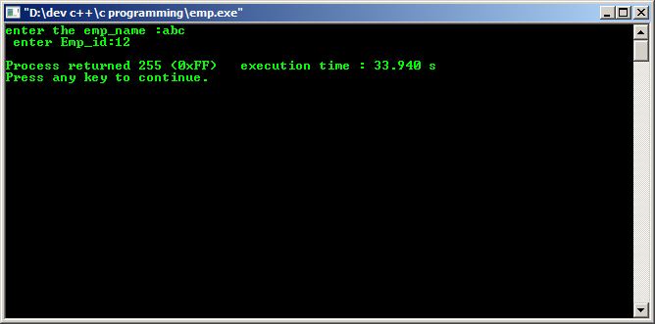

**5)**

**#include <stdio.h>**

**int main()**

**{**

**int a,b,c,d,e, total;**

**char name[10];**

**printf("enter the student_name :") ;**

**scanf("%s", name);**

**printf(" enter sub1 mrks:");**

**scanf("%d", a);**

**printf(" enter sub2 mrks:");**

**scanf("%d", b);**

**printf(" enter sub3 mrks:");**

**scanf("%d", c);**

**printf(" enter sub4 mrks:");**

**scanf("%d", d);**

**printf(" enter sub5 mrks:");**

**scanf("%d", e);**

**total=a+b+c+d+e;**

**printf(" total is =%d \n",total);**

**getch();**

**}**